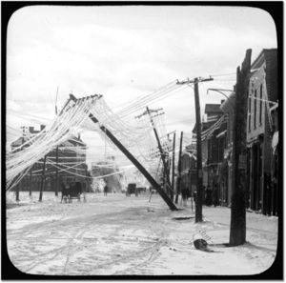
Ice Storms
- Overview
- Description
- Formation
- Destruction
- Ice storm vodcast
- Case Study – “Ice Storm of 1998”

This website was designed by the 2008 James Scholars in ATMS 120 at the University of Illinois at Champaign-Urbana. It was made to provide interesting information about the weather associated with ice storms and the destruction they cause. Here you will find a vodcast and a case study about the devasting ice storm of 1998.

2008
Katherine Crane, Howie Leibach, JoAnn Park, Chinonyelum Nwosu
James Scholars
11/9/2008

Crack! Snap! Boom! That is the sound of a tree breaking and hitting the ground. Why? This tree has been weighed down by the massive amounts of ice that covered its branches from a severe ice storm. Ice storms are brutal storms that wield supercooled rain (rain that has been cooled between 27ºF and 32ºF, which freezes on contact with a surface) and snow as weapons. Eastern Canada and New England are the two most popular areas for freezing rain, and collect on average of twenty to forty hours of freezing rain per year. There is almost no freezing rain to the south along the Gulf of Mexico and in the western Great Plains. 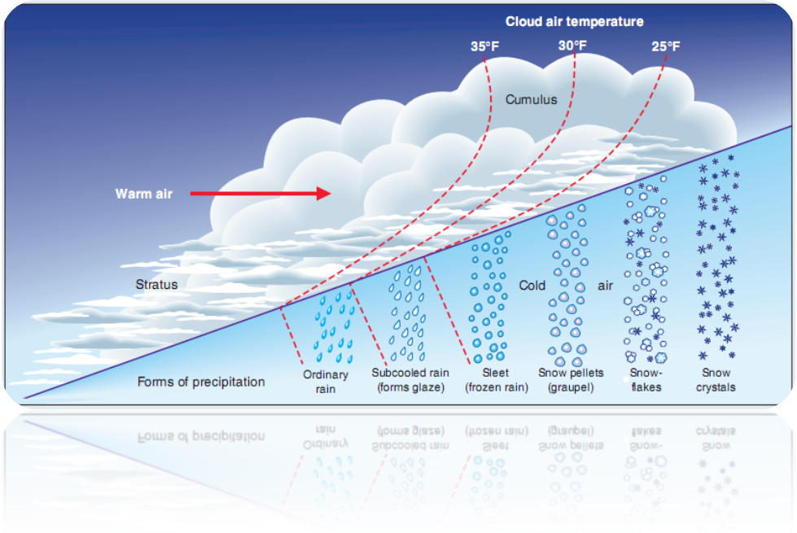
Figure 1: A diagram of the different forms water has at certain temperatures. This picture is courtesy of http://web.extension.uiuc.edu/forestry/publications/pdf/urban_community_forestry/trees_and_ice_storms_2006.pdf
Ice storms typically occur during the months of December and January, when temperatures are low enough to support freezing rain. Freezing precipitation can occur at any time of the day, but it is two times more likely to occur early in the morning before sunrise than later in the afternoon. At pre-dawn, ground surface is at its coldest and the surface-based temperature inversions are most common. An ice storm warning is issued by the National Weather Service when freezing rain produces at the least ¼ of an inch accumulation of ice. The Midwestern and Eastern regions of the United States see the most frequent occurance of freezing rain events as shown in Figure 2.
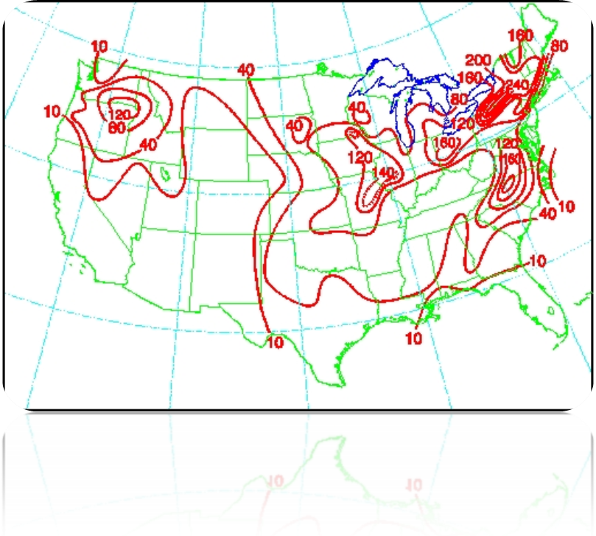
Figure 2: Number of hourly freezing rain observations 1982-1990. This picture is courtesy of http://www.crh.noaa.gov/dvn/?n=freezingrain

Areas that are most often hit by these storms are central North Carolina, West Virginia, Pennsylvania, New York, the Columbia River Valley in southern Washington, and northern Oregon. One of the most severe ice storms is the Oklahoma Ice storm of January 29-31, 2002.

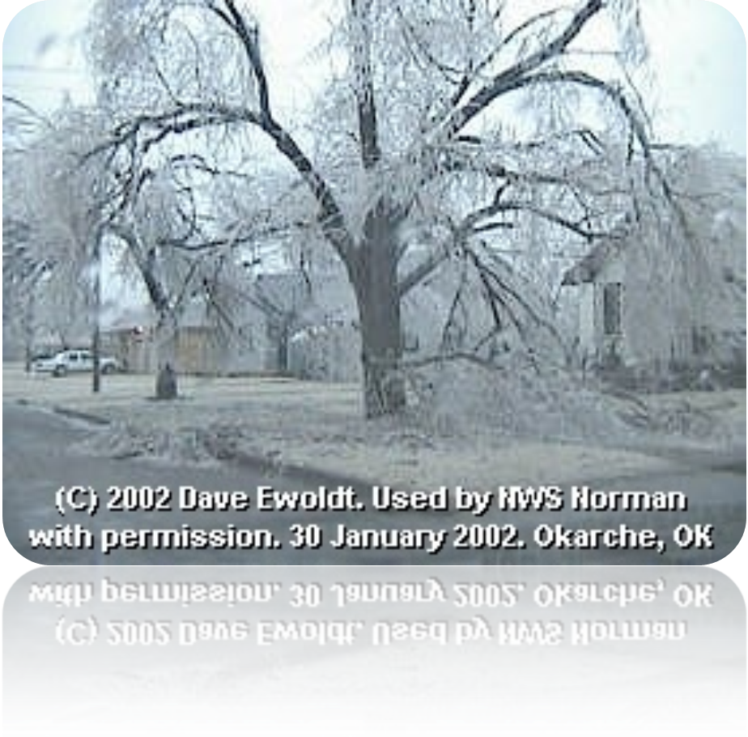
Figure 3: A common site from the Oklahoma Ice Strom of 1998. This picture is courtesy of http://www.srh.noaa.gov/oun/storms/20020129/index.html.

One very recent severe ice storm hit Oklahoma in January 29-31, 2002. This large winter storm brought four different types of precipitation: rain, freezing rain, sleet, and snow to Oklahoma hitting it hard by taking down power lines, trees, and telephone lines, as well as causing massive power outages across the state leaving 250,000 people in the dark and the cold. These storms produce an extraordinary amount of damage, which cost hundreds of millions, even billions of dollars to clean up and repair damaged structures, One of the most expensive, single ice storms in recent history was the ice storm that occurred February 9-13, 1994, which required $3 billion for cleanup costs across the Southeastern U.S. because of all the damage that the ice caused by bringing down power lines and trees, as well as additional damage caused by ice.
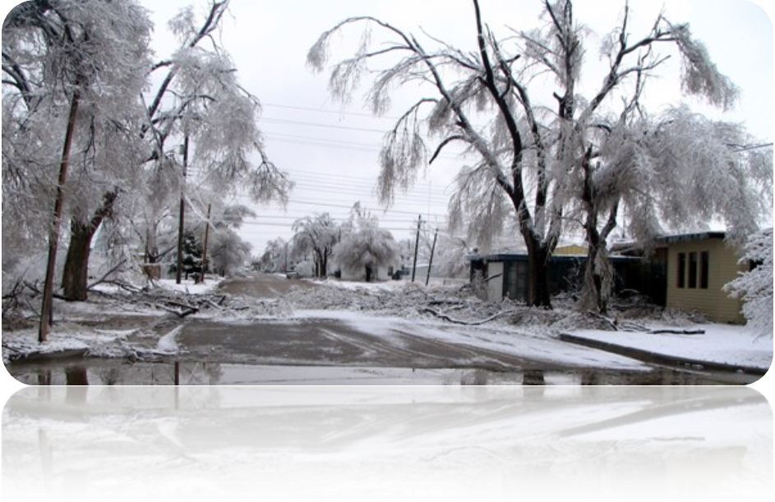
Figure 3: A look at the debilitating damage caused by the Oklahoma Ice Storm of 2002. This picture is courtesy of http://www.ok.gov/OEM/images/20061220-0icestorm.jpg
Although the Oklahoma ice storm of 2002 and the February 1994 ice storm were massively destructive, they are not the worst ice storms to hit the United States, this title belongs to the 1998 ice storm that hit the northeast U.S. and southeast Canada; the so-called “Great Ice Storm of 1998”. The storm started January 5, 1998 and continued through January 10, 1998 impacting both Canada and the United States. The “Great Ice Storm of 1998” caused 1.4 billion dollars in damage and killed sixteen (16) people in the United States. This storm dropped close to ten (10) inches of sleet in some areas of Maine, between a one eighth 1/8 and 3 inches of ice in various areas and more than two feet of snow in others. Millions were affected by this storm, between the states of New York, New Hampshire, Maine, and Vermont where 1,073,000 lost electricity, some people even going without power for as long as 21 days. Ice storms like these can produce damage on a variety of levels ranging from downed phonelines and treacherous roads, to leaving millions powerless and entire forests destroyed. Regardless of their strength, ice storms are a formidable part of winter storms that frequently leave behind a path of destruction.
Description:

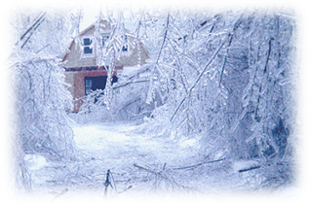
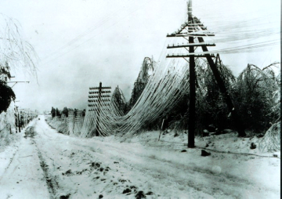Ice storms, produced by freezing rain, are one of the most dangerous weather occurrences in the world. Freezing rain accounts for a quarter of all winter related events in the U.S. and half of these develop into ice storms. Ice storms are classified by their structural damage or by the approximate accumulation of 0.25 inches of ice or more [1]. Minor glazes of ice is hazardous for traffic and pedestrians, but the real severity of ice storms are seen in full effect by the extensive power outages, halted air and ground transportation, and considerable property damage. Since the 1950s, there has been a $16 billion loss of property due to ice storms [1]. And although infrequent in the South, this part of the country experience the greatest number of insured property losses exceeding $1 million [1].
Figure 1: Frozen Power Lines Courtesy of Intute: Science, Engineering and Technology
Figure 2: Everything Glazed in Ice Courtesy of Hearth.com Articles
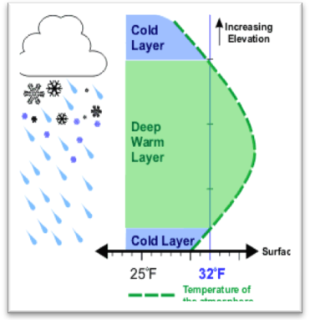
Two essential elements are required to generate freezing rain: a deep warm layer (above freezing) over a shallow cold layer at the surface that has temperatures below freezing [4]. Whether the precipitation is rain or snow, as it passes through the warm layer, it is converted into rain. Then as the rain passes through the cold shallow layer just above the surface, its internal temperature drops below the freezing point of water (32°F 0°C), however, the raindrop remains a liquid; a phenomenon called supercooling [4]. When this supercooled liquid water drop hits a surface that has a temperature below freezing, it immediately freezes upon contact. This process can be visualized in Figure 3.
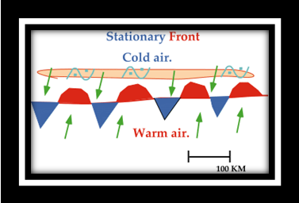
There are many weather patterns associated with freezing rain east of the Rocky Mountains. Two of the most common weather patterns, those responsible for 2/3 of freezing precipitation, are focused around the arctic front and warm front in the extra-tropical cyclone [1]. Other weather patterns include cold-air damming and cold-air trapping, which are most frequent along the Appalachian Mountains. In nearly all freezing rain weather patterns, the zone of freezing precipitation is narrow, usually less than 160 km (100 miles) across and is formed as warm moist air overruns cold air at the surface in the vicinity of these fronts [5]. If the front is immobile (like the stationary front depicted in Figure 4), it allows the zone of freezing rain to remain at the same location for a long time, allowing enough accumulation of glaze to produce a devastating ice storm. Two such examples include the 2002 January ice storm in Oklahoma and the “Great Ice Storm of 1998” in the northeast U.S. and southeast Canada.
Figure 3: Supercooling Courtesy of National Weather Service
Figure 4: Stationary Front Courtesy of atmos.uiuc.edu

Formation
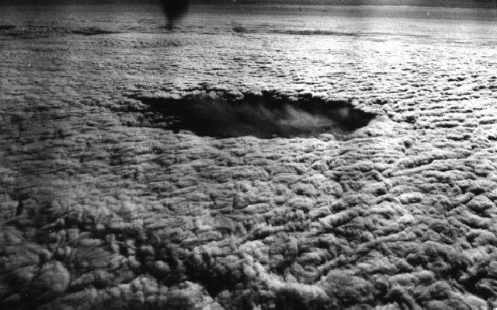
Freezing precipitation can be classified into two different categories, freezing rain and freezing drizzle. Each occurrence involves different processes in which they form, and each presents different hazards. A common misconception is that when the temperature is less that 32⁰ F or 0⁰ C then freezing precipitation will fall. This is not always true because supercooled water plays a large role in the formation process. For a molecule of pure water to form into
Ice on a supercooled cloud courtesy of Penn State College of Earth and Mineral Sciences

an ice lattice structure the temperature actually needs to be about -40⁰ C. Because our atmosphere is filled with many microscopic particles including dust, organic particles, and many others, water is able to freeze most effectively into an ice lattice at temperatures between -15⁰C (5⁰F) and -5⁰C (23⁰ F). The small microscopic particles, which provide attachment sites for water molecules to form their lattice, are referred to as ice nuclei. Ice crystals can form somewhat effectively between the temperatures -5⁰C (23⁰F) and 0⁰C (32⁰ F) with the help of these ice nuclei. Water will only supercool and remain liquid without the presence of ice nuclei.^{[1]} Freezing rain is formed through the melting process and usually occurs in deep clouds. This kind of freezing precipitation is most commonly known as ice pellets or sleet. It is most easy to think of the atmosphere in three layers when describing how freezing rain is formed. Snow is present in the uppermost layer. The snow then travels down to a layer where the temperature is greater than 0⁰C and melts into raindrops. As the raindrops fall into the next layer where the temperatures are less than 0⁰C, they supercool. When the raindrops reach the surface, they freeze on contact with objects forming a glaze. When starting from the surface and moving up, we can see that the temperature is increasing with height for a period of time, and then decreases again. When temperature increases with height it is called an inversion.^{[1]}

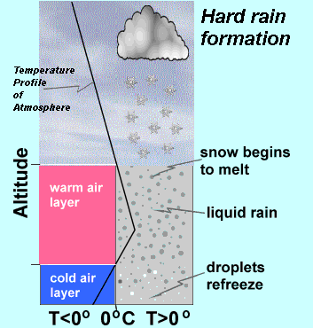

Temperature profile for freezing rain formation courtesy of Keith C. Heidorn “The Weather Doctor”

The supercooled warm rain process, which usually occurs in shallow clouds (1 to 3 km), is yet another way for freezing precipitation to form. The entire cloud is supercooled during this process usually having a temperature of about -10⁰C to -15⁰C. This is the optimal temperature range for the ice nuclei to be most effective. This process does not involve snow, and usually results in what is called freezing drizzle.^{[1]} Freezing drizzle does not fall as frozen precipitation; rather it falls as a misty rain that freezes on contact with cold surfaces. Rain droplets form because cloud drops collide and come together. Freezing drizzle drops have diameters from about 0.2 mm to about 0.5 mm. Supercooled clouds can pose danger for aircrafts, and glaze accumulation results in hazardous road conditions.^{[1]}
The weather patterns that commonly accompany freezing precipitation are arctic fronts, warm fronts in cyclones, southerly flow, and cold air damming along the Appalachian Mountains. Arctic fronts account for about a third of all freezing precipitation events east of the Rocky Mountains, while warm fronts in cyclones account for about one third of events in the U.S., southerly flow accounts for about one-tenth, and cold-air damming causes about 15 percent of events east of the Rockies.^{[1]} The zone of freezing precipitation associated with each of these weather patterns is usually less than 100 miles across.^{[1]} The storm itself is usually about 30 miles to 300 miles across.^{[2]} This narrow band always moves with the moving weather pattern. “In most cases, this results in transition either from freezing precipitation to ice pellets and snow, or freezing precipitation to rain over the course of a few hours.”^{[1]}
Arctic Fronts
Arctic fronts flow from Canada and move southeastward across the U.S. As the front, which is followed by a high pressure system, approaches the Gulf of Mexico warm air rises over the cold air dome, forming a shallow cloud layer that creates freezing drizzle. In southern states, deep clouds that produce freezing rain can form from warm, unstable air overrunning the arctic air mass.
Warm Front of a Cyclone
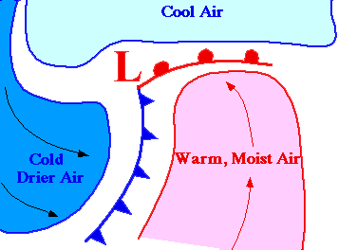
A low pressure system associated with a cyclone is developed due to an approaching warm front. Consequently, warm fronts develop best in the winter.^{[4]} The freezing precipitation occurs in a narrow band ahead of the warm front.^{[3]} About half of the time,

Freezing precipitation due to a warm front associated with a cyclone. Courtesy of University of Illinois Dept. of Atmospheric Sciences

a cyclone will be accompanied by a high pressure system to the north. Winds rotate counterclockwise along the low pressure center.^{[4]} The winds force air upward where it will condense into clouds. Stronger winds will be over the area where freezing precipitation is likely to fall. This results in greater potential for damage.^{[1]}
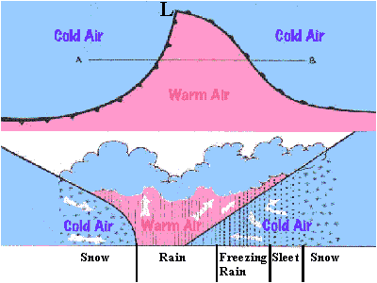
Low pressure system and temperature separation. Courtesy of Keith C. Heidorn “The Weather Doctor”

Southerly Flow
Southerly flow results in freezing precipitation falling over a more circular area rather than in a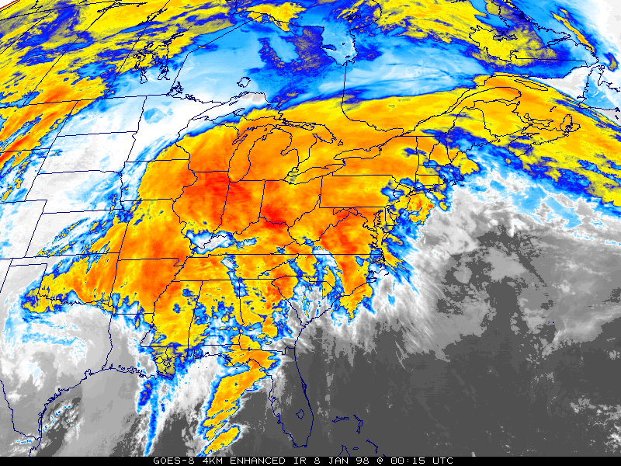
Infrared satellite image of a storm system with deep southerly flow during the week of Jan. 5-9, 1998. It produced a severe ice storm in parts of the northeast U.S. and into Canada. Couresty of the NWS.

band.^{[1]} Warm moist air from the south collides with a slow moving low pressure system and is forced upward. As the air moves up, it cools and freezes. ^{[2]}
Cold-air damming
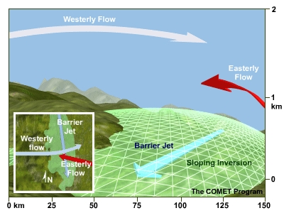
Freezing precipitation occurs around the Appalachian Mountains through processes know as cold-air damming. Cold-air damming results in freezing precipitation on the east side of the mountain range.^{[1]} Ice storms due to CAD are hard to accurately predict. CAD events will have widespread cloudiness and very low temperatures. For cold-air damming to occur there must be a sloping inversion on the side of a mountain range, warm moist air flowing from the east or the west, and a barrier jet. A barrier jet develops with low level winds and a low pressure system. One source of the cold air

Picture of cold-air damming courtesy of METED

Destruction
Freezing precipitation has caused over 16 billion in property losses in the United States alone and accounts for 20 percent of all winter-related injuries. About 70% of these injuries result from vehicle accidents. The average victims susceptible to ice storms are males over 40 years old (13). Heavy ice accumulation can bring down trees and topples utility poles and communication towers. Consequently, ice storms can disrupt communication between cities for days on end as they lose power and proper means of transportation. Road surfaces become damaged as well. Bridges and overpasses have a tendency to freeze before other types of surfaces and thus increase the risk of traveling during ice storms. Building infrastructures are vulnerable as well. Pipes can freeze and burst in poorly insulated homes. Insured property losses from ice storm events in the U.S. average 326 million dollars per year in damages (13). The agricultural sector is punished by ice storms as well. Freezing temperatures can cause severe damage to citrus fruit, crops and vegetation with damages recorded as high as 1.6 billion dollars in total damages per agricultural season (13). Although there is no record of deaths per year due to ice storms, the affects of ice storms attribute to the total deaths per year equating to 47 deaths per year (U.S.) (12).
Damages
Ice storm damages are insurmountably high partly due to ice pillage. In perspective, the weight of ice on a power line for a 300 ft span of power lines that are 1" thick coated with 1/4 inch of ice, adds 117 lbs. of weight to the object. Coated with 1/2 inch, the added weight is 281 lbs, coated with 1", the added weight is 749 lbs and coated with 2", the added weight is 2248 lbs. For a 1500 foot span of power line the added weight of 2 inches of ice is 11242 lbs! Overall, Accumulations of ice can increase the branch weight of trees by 30 times its original weight. The average annual property damage loss in ice storms based on an 8 year period is 226 million dollars and accounts for about 60 percent of winter storm damages (11).

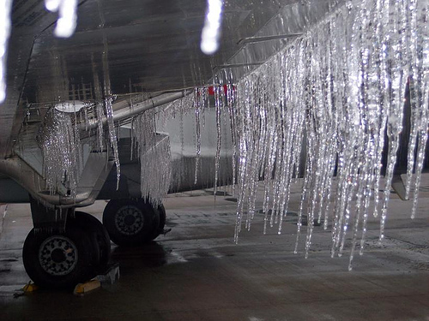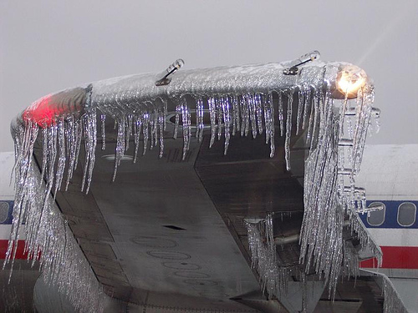
http://images.google.com/imgres?imgurl=http://farm3.static.flickr.com/2335/2108315551_2d52a66fcf.jpg&imgrefurl=http://crankyflier.com/2007/12/13/frozen-airplane-porn/&usg=__qcHSwKeFFo7XmzTJvTXD6YnBi9Y=&h=375&w=500&sz=109&hl=en&start=1&sig2=y-ti_jEQhYfeBjucUE-7xQ&tbnid=iASXGnBDwTGvbM:&tbnh=98&tbnw=130&ei=-OodSa3uEZrUMcSF2fsJ&prev=/images%3Fq%3Dfrozen%2Bairplane%26gbv%3D2%26hl%3Den%26sa%3DG
The accumulation of ice can also damage airplanes. If freezing drizzle droplets in clouds grow to above .04 mm, they collect on the wings of aircrafts. Ice can and has accumulated to crash airplanes.
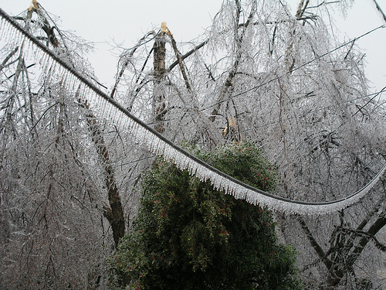
http://farm3.static.flickr.com/2185/2078343483_cec8c70f56.jpg

Destructive Regions
Most ice storm catastrophes occur in the Northeast, Central Southeast, and South climate regions. The maximum and average ice thickness is relatively the largest in New England and in the general Northeast however the South’s ice storms are the most devastating. In contrast, Ice-thickness is the lowest in the upper Midwest and Pacific Northwest (15). Ultimately, the greatest risk of ice storm damages is in the Northeastern United States followed by the Lower Midwest and the south. Storm-area sizes ranged from 205 to 796 000 km2 with the greatest area’s (per km2) being in the Eastern US (15).
Preventative Measures
The National Climatic Data Center's (NCDC) Research Customer Service Group collaborated with the U.S. Army's Cold Regions Research and Engineering Laboratory (CRREL) to provide preventative steps in regard to freezing rain. Overall, Ice storms are economic catastrophes which can and have forcefully dismantled cities and parks and have capabilities of disrupting air and land transportation. Because of new technology, ice formation forecasts save our country 29 million dollars per year in damages while the Integrated Icing Diagnostic Algorithm saves 33.7 million dollars in plane damages per year (11).

http://www.srh.noaa.gov/srh/jetstream/synoptic/precip.htm
www.na.fs.fed.us/urban/inforesources/TreesIceStorms2ed.pdf
http://web.extension.uiuc.edu/forestry/publications/pdf/urban_community_forestry/trees_and_ice_storms_2006.pdf
http://www.ci.savannah.ga.us/cityweb/disasterinfo.nsf/5ae9bd7c8938f28a85256b88006d8e15/973ecbe69ed086d585256c2400535911?OpenDocument
http://www.srh.noaa.gov/oun/storms/20020129/index.html
http://ols.nndc.noaa.gov/plolstore/plsql/olstore.prodspecific?prodnum=C00490-PUB-A0001
http://www.fs.fed.us/na/durham/ice/
http://books.google.com/books?id=mHbKk4xFzigC&pg=PA356&sig=eroUg9ejU9IS-UP4OBSOIgOhFTs&dq=northeast+ice+storm+of+1998+%22January+1998%22+%22Northeast+ice+storm,+January+1998.+%22+%22Ice+storm+hits+northern+sections+of+New+York,+New+Hampshire,+Maine,+and+Vermont.+%22+%22Damage+of+%241.4+billion+with+16+deaths.+%22
http://www.fs.fed.us/na/durham/ice/public/pub_file/ice99.pdf
http://imiuru.com/icestormdiary/1pages/factsfigures.html 11http://www.economics.noaa.gov/?goal=weather&file=events/snow 12http://ams.allenpress.com/archive/1520-0477/80/6/pdf/i1520-0477-80-6-1077.pdf 13http://www.nws.noaa.gov/om/winterstorm/winterstorms.pdf 14 http://web.aces.uiuc.edu/vista/pdf_pubs/ICESTORM.PDF 15. Stanley Changnon, Characteristics of Ice storms in the US PDF. U OF I. Description: 11.Rauber, Robert, and John Walsh, and Donna Charlevoix. Severe and Hazardous Weather. Kendall/Hunt Publishing Company, 2005. 2. Intute > Science, Engineering and Technology Figure 1: Power outage http://www.intute.ac.uk/sciences/blog/wp-content/uploads/2007/12/ice_storm.jpg 3. Figure 2: Trees Glazed by Ice http://hearth.com/econtent/images/uploads/ice1-104.gif 4. Figure 3: Supercooling Precipitation: National Weather Service. 17 Dec. 2007 http://www.srh.noaa.gov/srh/jetstream/synoptic/precip.htm 5. Figure 4: Stationary Front Cyclones and Fronts: the development of freezing rain. http://ww2010.atmos.uiuc.edu/(Gh)/guides/mtr/cld/prcp/zr/cond/cyc.rxml 6. Freezing Rain: supercooled droplets freezing on impact. http://ww2010.atmos.uiuc.edu/(Gh)/guides/mtr/cld/prcp/zr/frz.rxml

